Certificate in Quantitative Finance

Interest Rate Modeling for Counterparty Risk

Ignacio Hamel

July 15, 2019

Contents

Chapter 1 3

CVA IR definition 3

LIBOR Definition 5

How Is LIBOR Calculated? 5

OIS Definition 6

Black model 7

LIBOR market model definition 9

Bootstrapping 12

CDS and Hazard Rates 13

Chapter 2 16

Implementation for Libor market model and CVA Model 16

Step 1: Getting the Curves Data and Bootstrapping 16

Step 2: Getting the Correlation matrix 20

Step 4: Libor Market Model Run 26

Step 5: Working with the Libor Market Model Rates 28

Step 6: Calculating the NPV Path and exposures 30

Step 7: Calculating the default probability and CVA 33

Sensitivity analysis 38

Conclusions 39

References 40

# Chapter 1

## CVA IR definition

CVA or credit counterparty value adjustment is an adjustment that’s applied to a derivative to take in count the credit risk for counterparty. CVA has become a key topic for banks in recent years due the volatility of credit spreads and the capital requirements (Basel 3).

CVA was originally introduced as an adjustment to the risk free value of a derivative to account for potential default via relationship

There is a hidden complexity in this equation, which is that it is not naturally additive across transactions. Due to risk mitigants such as netting and collateral, CVA must be calculating for all transactions covered by the risk mitigants.

The standard formula for computing of CVA is

Where:

LGD: Percentage amount of the exposure expected to be lost if the counterparty defaults.

EE: Expected exposure, is the discounted expected exposure for the relevant dates in the future given by for i = 1,m.

PD: Default probability. To calculate we requires the marginal default probability in the interval between date and given by

Pricing the credit risk for an instrument with one pay-way payments, such a bond, is relatively straightforward, only need to account for default when discounting the cash flows and add the value of any payments made in the event of a default. Many derivatives instruments have fixed, floating or contingent cash flows or payments that are made in both directions. This bilateral nature characteristic credit exposure makes the quantification of counterparty risk more difficult. That’s why we have to implement rates and risk models to calculate CVA.

## LIBOR Definition

The London Inter-bank Offered Rate (LIBOR) is a [benchmark](https://www.investopedia.com/terms/b/benchmark.asp) interest rate at which major global banks lend to one another in the international interbank market for short-term loans.

LIBOR serves as a globally accepted key benchmark interest rate that indicates borrowing costs between banks. The rate is calculated and published each day by the [Intercontinental Exchange (ICE)](https://www.investopedia.com/terms/i/intercontinentalexchange.asp).

LIBOR is the average interest rate at which major global banks borrow from one another. It is based on five currencies including the US dollar, the [euro](https://www.investopedia.com/terms/e/euro.asp), the British pound, the Japanese yen, and the Swiss franc, and serves seven different maturities—overnight/spot next, one week, and one, two, three, six, and 12 months.

The combination of five currencies and seven maturities leads to a total of 35 different LIBOR rates calculated and reported each business day. The most commonly quoted rate is the three-month U.S. dollar rate, usually referred to as the current LIBOR rate.

## How Is LIBOR Calculated?

The ICE Benchmark Administration (IBA) has constituted a designated panel of global banks for each currency and tenor pair. For example, 16 major banks, including Bank of America, Barclays, Citibank, Deutsche Bank, JPMorgan Chase, and UBS constitute the panel for US dollar LIBOR. Only those banks that have a significant role in the London market are considered eligible for membership on the ICE LIBOR panel, and the selection process is held annually.

The IBA calculates the LIBOR rate using a [trimmed mean](https://www.investopedia.com/terms/t/trimmed_mean.asp) approach applied to all the responses received. Trimmed mean is a method of averaging which eliminates a small specified percentage of the largest and smallest values before calculating the mean. For LIBOR, figures in the highest and lowest quartile are thrown out and averaging is performed on the remaining numbers.

## OIS Definition

Overnight indexed swap (OIS) it’s an overnight rate calculates for Federal Fund reserve daily.

The index rate is typically the rate for overnight unsecured lending between banks.

The LIBOR–OIS spread is the difference between LIBOR and the OIS rates.

An overnight indexed swap is an interest rate swap where the periodic floating payment is generally based on a return calculated from a daily compound interest investment. Having this Yield zero curve, we can calculate all the VP for any derivative with this curve, because represent the interbank market to finance all the collaterals (After the last financial crisis market use that way).

## Black model

The Black model (sometimes known as the Black-76 model) is a variant of the Black–Scholes option pricing model. Its primary applications are for pricing options on future contracts, bond options, Interest rate cap and floors, and swaptions.

Black's model can be generalized into a class of models known as log-normal forward models, also referred to as LIBOR market model.

The black formula is similar to the Black–Scholes formula for valuing stock options except that the spot price of the underlying is replaced by a discounted futures price F.

Suppose there is constant risk-free interest rate r and the futures price F(t) of a particular underlying is log-normal with constant volatility σ. Then the Black formula states the price for a European call option of maturity T on a futures contract with strike price K and delivery date T´(with T´>= T)

]

The put price is

]

Where

Now if we consider an accrual period [ , a caplet with strike K, notional N and maturity in an European call option on the spot rate have payoff

The Libor rate star fixed at time , after the reset date the value of the caplet becomes deterministic.

To obtain the value for time , we use the risk neutral pricing formula, which give us the -forward measure . With that, we have

To evaluate this caplet we need to make an assumption about the dynamics of the underlying. Black model assumes a log-normal process

Were denotes the volatility (a constant). The derivative is taken with respect to t and (t) denotes a Brownian motion under . With that we get

Where is the cumulative distribution function of the standard normal distribution.

We will use this Caplet formula to calibrate the Libor Market Model

## LIBOR market model definition

Financial derivatives market constitutes a big portion of the financial market and interest rate derivatives play a very important rol. This market is huge and famous for its complexity. There are many types of rate, but in this work we will talk about LIBOR rate and their derivative market.

To LIBOR vs FIX derivatives rates we can calculate forward rates for each tenor. For a full exposure analytics for CVA can be produced by a model that simulates the full curve suitably, and has to be calibrated on the recent data. Short rate modesl was the first attempt and the basic approach to pricing, assuming an instant rate and a stochastic process that this rate follows, but this model assumes only one source of randomness and all forward rates are perfectly correlated.

To price correctly, we need that the term structure can change its slope as market conditions changes. In extreme events might be totally different from ¨normal¨structures.

LIBOR market model allows all forward rates to be random; this allows us to get any shape of term structure. This model allows us that all forward rates are random, though they may be correlated. This model also allows us choose the form of volatility and correlation functions, which control the joint distribution of all rates. With this flexibility we have more accuracy to fit market data and model real world situations.

We will assume that the Libor market model assumes a log-normal process for each

that’s it

for i = 1 to n

Where is the instantaneous volatility (Different for the Black model) and a Brownian motion under

We assume that the Brownian motions are correlated via

Where a constant matrix (instantaneous correlation)

The difference between the dynamics of a forward rate in the black model vs Libor

market model it the time dependence of the volatility. Libor Market Model can be viewed

as a set of correlated Black models.

The payoff of interest rate products can depend on all forward rates ,

With . When we price such product via Libor Market model using

Montecarlo method, we have to evaluate the expectation of such payoff. This requires

to express the dynamics in of all forward rates

under a common measure. We will use the measure (terminal measure). Using the

change of numeraire technique, it can be shown that under the dynamics becomes

Were:

In this work, we will have to implement the dynamics of this model in Python

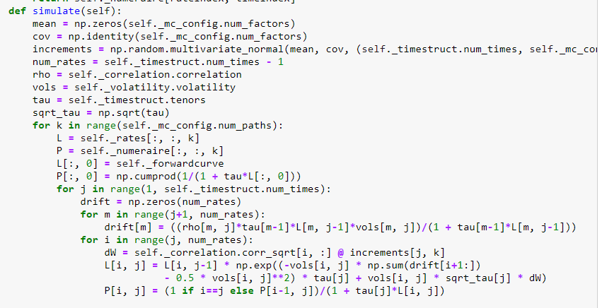

Table 1: Code in python for the Libor Market Model implementation.

We will explain this in detail in Chapter 2.

## Bootstrapping

Bootstrapping is a method for constructing Zero coupon yield curve from prices of a set of coupon products, for example swap libor IRS.

For each stage of the iterative process, we are interested in deriving the n-year zero-coupon bond yield, also known as the internal rate of return of the zero-coupon bond. To derive this rate we observe that the theoretical price of a bond can be calculated as the present value of the cash flows to be received in the future. In the case of swap rates, we want the par bond rate (Swaps are priced at par when created) and therefore we require that the present value of the future cash flows and principal be equal to 100%.

Therefore

Where:

## CDS and Hazard Rates

A credit default swap (CDS) is a financial derivative or contract that allows an investor to "swap" or offset his or her credit risk with that of another investor. Most CDS will require an ongoing premium payment to maintain the contract, which is like an insurance policy.

A credit default swap is designed to transfer the credit exposure of fixed income products between two or more parties. In a CDS, the buyer of the swap makes payments to the swap's seller until the maturity date of a contract. In return, the seller agrees that – in the event that the debt issuer (borrower) defaults or experiences another credit event – the seller will pay the buyer the security's value as well as all interest payments that would have been paid between that time and the security's maturity date. A credit default swap is the most common form of credit derivative and may involve municipal bonds, emerging market bonds, mortgage-backed securities or corporate bonds.

One of the key tasks in the valuation of credit derivatives is the estimation of default and/or survival probabilities for individual names. The so called credit curve, that is, the term structure of such probabilities, is a fundamental input to the valuation of both single-name and portfolio credit derivatives. If a credit curve is estimated from prices or other observables corresponding to liquid securities for a given name, then we obtain risk-neutral default and survival probabilities for that name.

We will estimate default probabilities and the corresponding hazard rates from Credit Default Swap (CDS) spreads prices that we can observe in the market.

The key driver of the value of a single-name credit derivative is the time of default τ. In the mathematical modeling of these securities, τ is assumed to be a stopping time (in a filtration satisfying the “usual conditions”). The default probability up to time t is defined as the cumulative probability distribution function of τ

The corresponding survival probability, that is, the probability that no default

occurs until time t, is

The hazard rate corresponding to τ can be defined as the deterministic function h(u)

such that

provided such function exists (i.e., lnS(t) is absolutely continuous). Conversely, if S is differentiable one can obtain the hazard rate from the survival probability function as

One can equivalently write the hazard rate as a function of the probability of default:

As a basic example, note that the arbitrage price, P ̄(0,T), of the zero coupon bond (ZCB) with zero recovery rate delivering one unit of cash at time T can be expressed as the following risk-neutral expectation

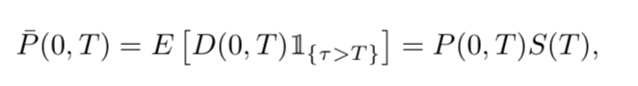

where:

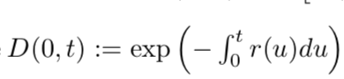

is the reciprocal of the money market numeraire, r is the risk-free short rate process, P (0, T ) is the corresponding risk-free ZCB price, and, crucially, we are assuming interest rates are independent of default times. Hence, survival probabilities are analogous to discount factors and can be read off the risk-free and risky discount curves:

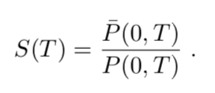

Note that absence of arbitrage implies that P ̄(0, T ) < P (0, T ), hence survival prob- abilities for non-trivial maturities are smaller than one. Note also that S(T) can be interpreted as the forward price of the risky ZCB maturing at time T.

Similarly, if survival probabilities are differentiable, hazard rates correspond the

the short rate of risk-less interest rate modeling. The price of a risky ZCB with

zero recovery can be written in “risk-adjusted” form:

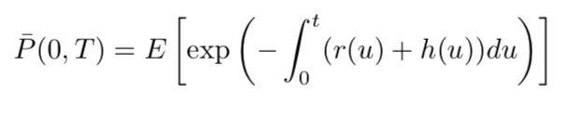

More generally, a zero coupon bond with random recovery rate5 R ̃ maturing at T has (pre-default) arbitrage price

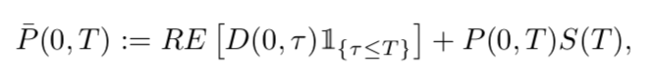

# Chapter 2

## Implementation for Libor market model and CVA Model

### Step 1: Getting the Curves Data and Bootstrapping

The basic idea behind a market model is to model interest rates directly observable in the market, which are the forward LIBOR rates in the case of the LIBOR market model.

The first step to implement the Libor market model is to have a zero coupon yield curve for spot market. We will take the spot market with the shape



Table 2: Spot rated used and definitions for 5y swap Libor

For the first part we will take the data from 13/02/2002 to 03/07/2019.

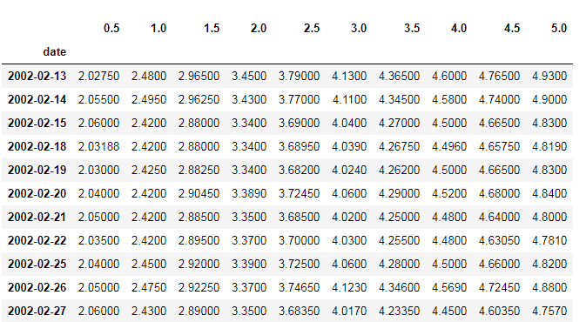

.

.

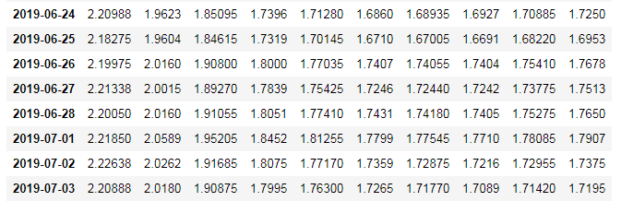

Table 3: Data Used

To start getting the data for the Libor Market Model, first we need to bootstrap the OIS Swap curve to obtain the Zero coupon OIS Yield.

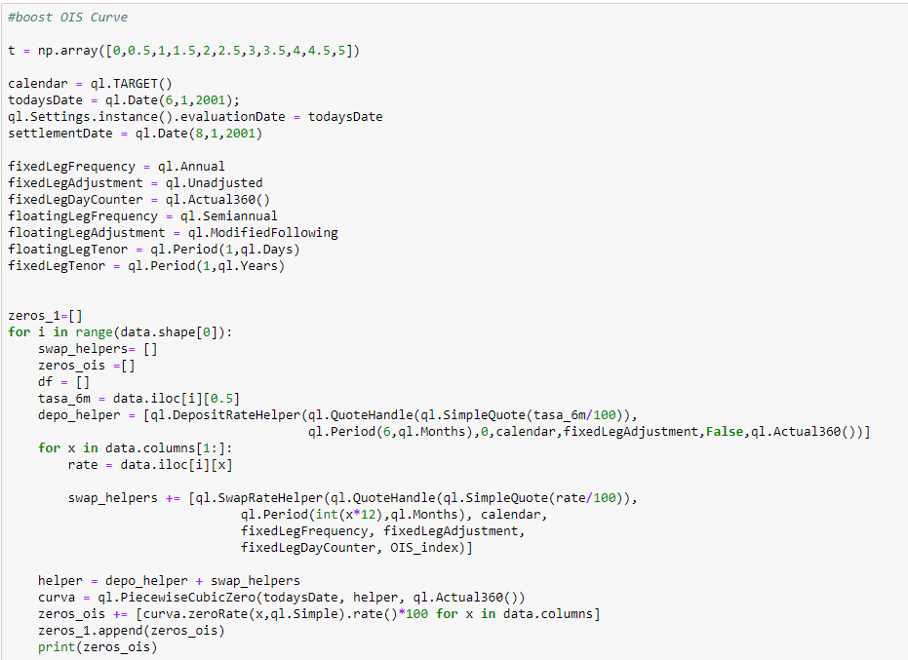

Table 2: : bootstrap method used to obtain Zero coupon OIS yield curve

Conventions used in swap OIS IRS market Curve

For the Fix leg:

Frequency: Annual

Day Count: Actual/360

For the floating leg

Frequency: Annual

Day Count: Actual/360

Now we can obtain the Zero coupon IRS Libor curve projecting the float leg to libor 6 months and discount from OIS Zero coupon Yield. For the fix leg we project with the fix rate and discount with OIS Zero coupon Yield.

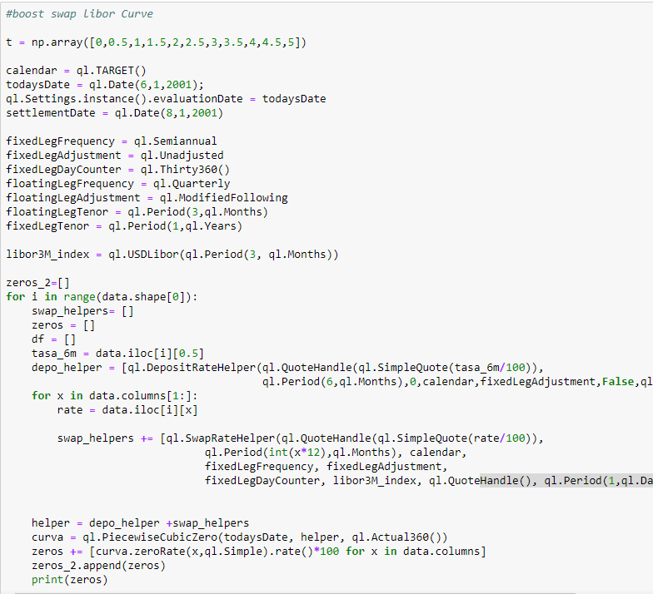

Table3: bootstrap method used to obtain Zero coupon yield curve

Conventions used in swap Libor IRS market Curve

For the Fix leg:

Frequency: Annual

Day Count: 30/360

For the floating leg

Frequency: SemiAnnual

Day Count: Actual/360

Were

Zero coupon rate discount = Zero OIS yield curve

Having the zero coupon curve, we can calculate the discount factor for each rate as:

Having the discount factors for each zero coupon rates, we can calculate the FRA for each rate as:

To run the model we will consider a set of dates

For i = 1 to n, we want the model forward libor rate for each period.

We will call as

### Step 2: Getting the Correlation matrix

To continue we have to calculate (the constan matrix explaned in the Libor

Market model definition).

For that, we need historical FRA Rates calculates before.

To calculate we use the FRA´s historical Curves and we calculate the correlation matrix between them in Python.

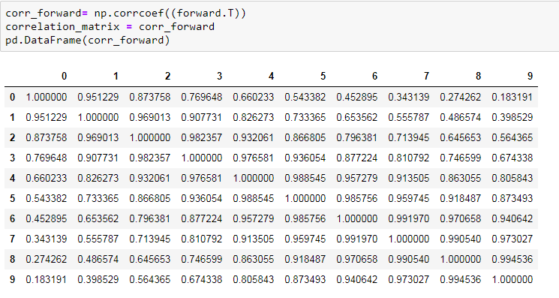

Table 4: Correlation Matrix for IRS Libor curve FRA´s

Unfortunately, a correlation Matrix obtained using this simple procedure presents most

of the time, spurious entries and irregularities which need to be smoothed out. To refine

and polish the historical correlation matrix we can use two simples mechanisms. One is

Smooth he curves used to obtain the time series of forward rates and they calibrate

parametric form to the historical correlation matrix. The second one (and the one that

we will use) is generate a Correlation Matrix using a method computes a rank

(where ) approximation of the correlation matrix and the corresponding -

dimensional pseudo-square root of the approximation (called factor reduction).

First we compute the eigenvalues and eigenvectors of the given correlation matrix

and order descendingly and take the first of those.

Second, we create the pseudo-square root, where the column vectors are and

compute a covariance matrix by squaring the the pseudo-square root.

Now we need to normalize it to obtain a correlation matrix. We do this by diving through

the standard deviations, i.e. square roots of the diagonal elements of the covariance

matrix.

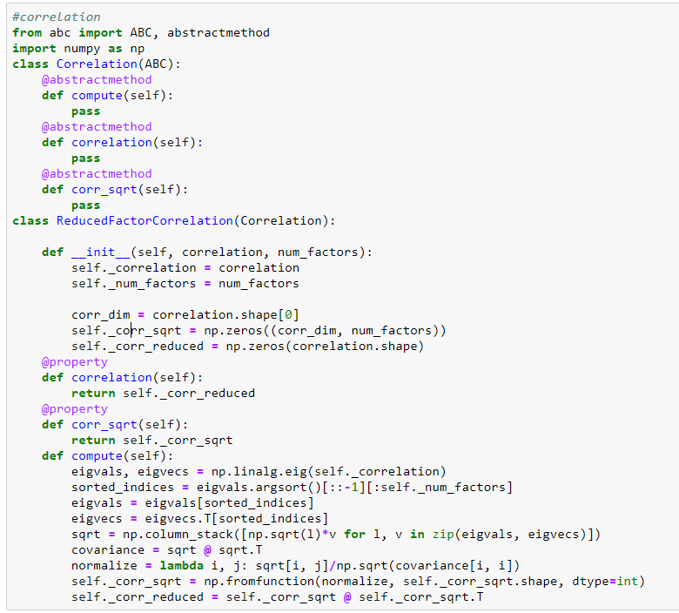

Table 5: Correlation model code in python.

Now we have our correlation matrix ready to be implement in Market Libor Model.

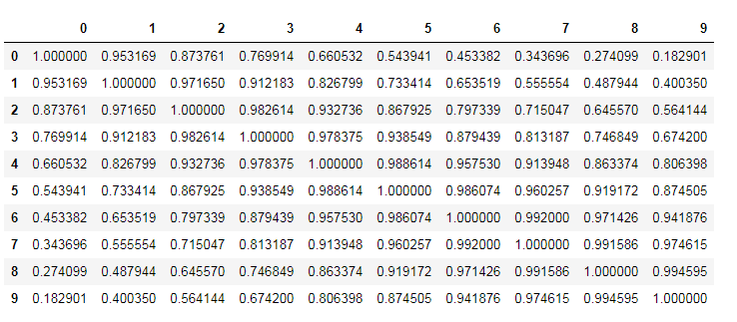

Table 6: Correlation matrix given by correlation model in Python.

Step 3: Getting the Market volatility and calibrate the model

To continue modeling, we need the caplet´s volatilities to calibrate the model. We will

take this from market.

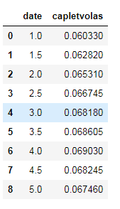

Table 5: Caplets IRS Swap Libor Volatilities

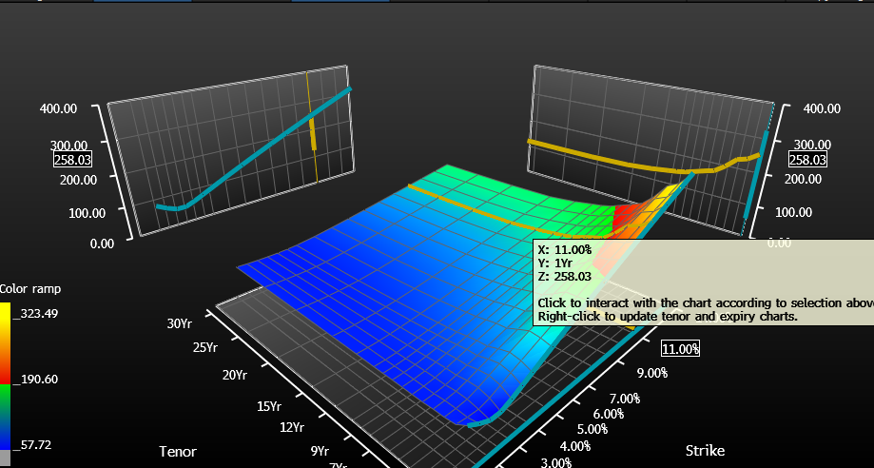

Grahp 1: bootstrap code used to obtain all Zero coupon yield curves

Our gold is to calibrate the Libor Market Model with market data, in this case to caplets. This mean that given market caplets volatility prices, we want to set the parameters in a way that the Libor Market model reproduces those prices as close as possible. (With this Caplets volatility we are going to perform a bootstrapping algorithm to calibrate the volatility functions of the Libor Market Model to implied caplet volatilities given).

Our choice for the volatilities is a time – homogeneous. Over each period the volatility is constant (only depends on the number of reset dates left to maturity)

We can describe this with

where =

We will have n constant parameters than we can use to calibrate to market data (Caplets).

Market quote caplet prices by their implied volatilities via the Black model, so if we like to know the price of a caplet for the accrual period we will have to insert the given volatility and insert in

(described in Black model definition)

In order to know we need to know how caplets are priced using Libor Market Model. We know that the only difference between the Libor Market Model and Black model is the time dependence of the volatility. We can obtain exact the same caplet pricing than Black model replacing in

The expression with

By equating the implied Black volatility ans the Libor Market Model volatility we get

Now, replacing with

With this

We obtain a bootstrapping formula and we can determinate

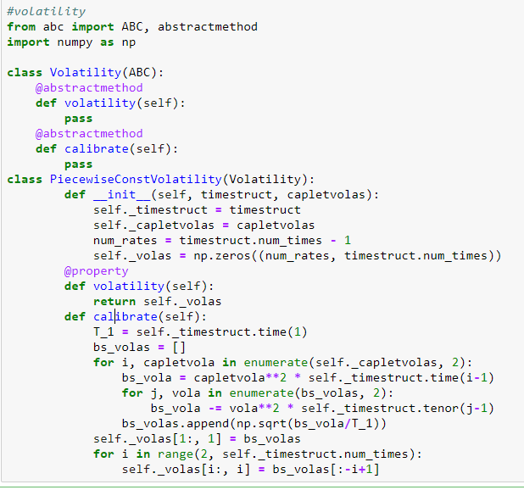

Table 6: Python code for bootstrap formula implemented for Volatility.

Implement this formula in Python is very simple and allows us to calibrate the Libor Market Model.

### Step 4: Libor Market Model Run

We have all set to simulate the forward curves in the Libor Market Model. The simulation is done via the Euler-Maruyama time stepping scheme describe before.

But intead of directly use the scheme describe before, we will use the scheme on the logarithm, which leads to a better convergence.

Where is the pseudo square root and a sample of a normal random variable.

By exponentiating we get the scheme used.

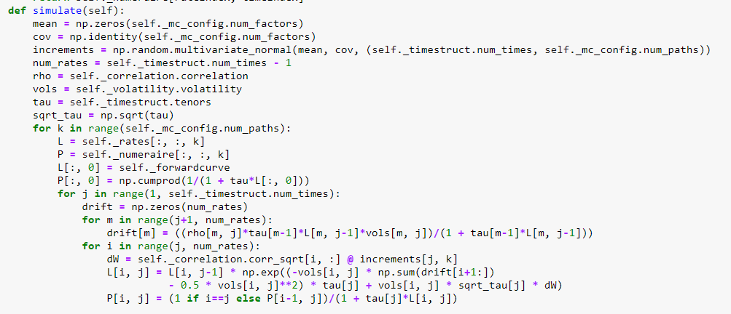

Table 7: Python code used to run the Libor Market Model.

We decide to run 2.000 simulations in the motecarlo model. After we will sensitize this variable.

Resuming, first we get all the market data, we config the montecarlo simulator, calibrate volatility, compute the correlation matrix and simulate the Libor Market Model.

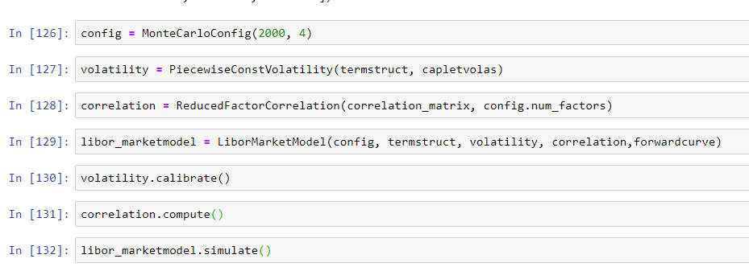

Table 8: Python code used to run the Libor Market Model for each step.

### Step 5: Working with the Libor Market Model Rates

The model gives us a cube of forward rates. We will use them to calculate the Net Present value for a Vanilla Swap Libor IRS with maturity 5 Yrs and notional 1. Fix rate 1.75%. Receiver for the Fix Leg.

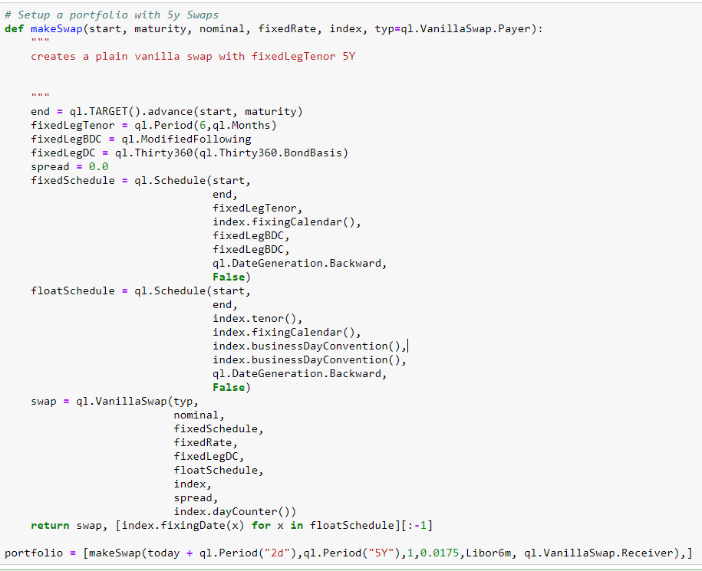

Table 9: Swap set in Python to evaluate with all the fw Rates of the Libor Market Model.

First we are going to calculate the Discount Factors for each tenor on the complete forward curve matrix. 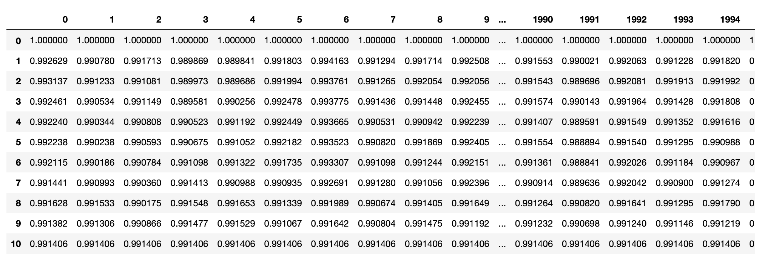

Table 9: Df´s calculates for each similation.

With this DF´s we will calculate the NPV value for the swap described before.

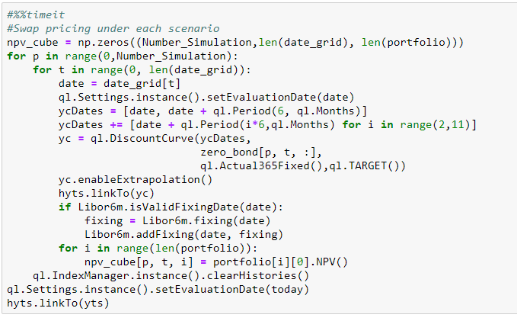

Table 10: Code used in Python to calculate the NPV values.

We obtain a set of NPV values (a Cube) with their values and their respective changes in NPV in time.

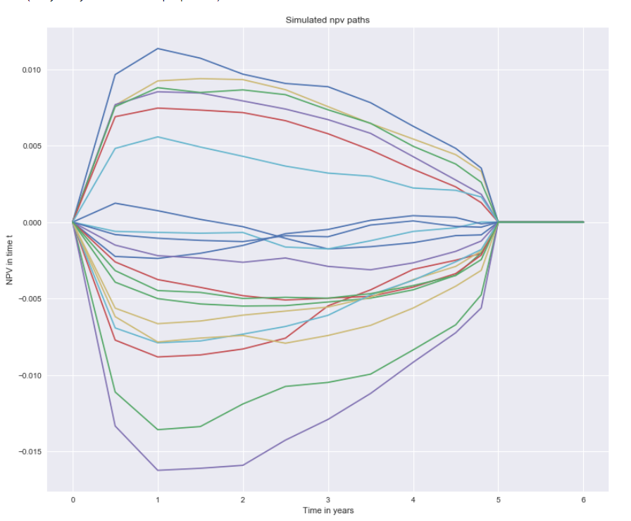

Grahp 2: First 20 NPV calculates for 5y swap with their time decay.

### Step 6: Calculating the NPV Path and exposures

Now that we have 2.000 paths for the NPV value in time we can calculate the exposure for the swap.

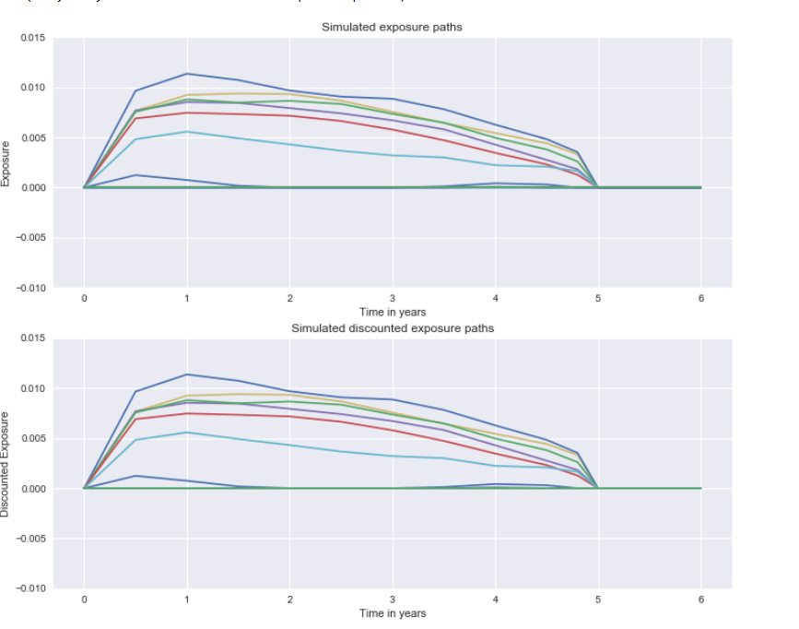

Graph 3: 20 first NPV exposure.

We can calculate the expected exposure (Average) path.

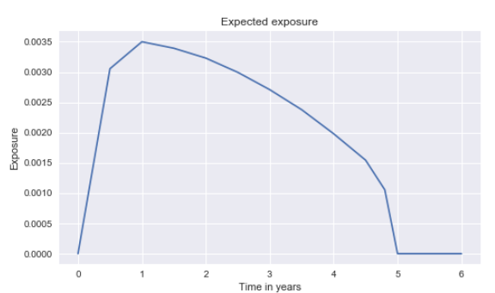

Graph 4: Expected NPV exposure in time.

We can see that the biggest exposure we can expect will be in 1 yr.

The maximum expected exposure is 0.0035 in 1 yr.

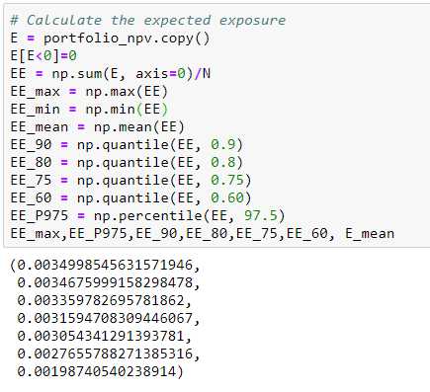

Table 11: Max, Percentile 97.5, Quantile 90, Quantile 80, Quantile 75, Quantile 60 and Mean expected exposure.

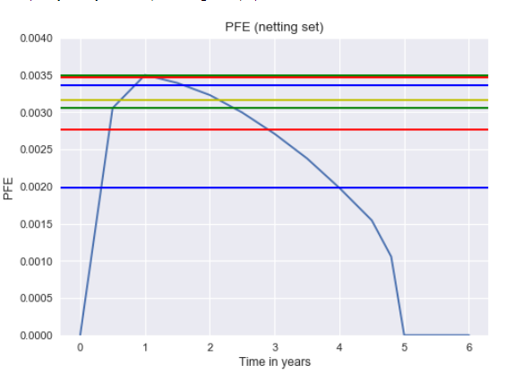

Graph 5: Expected NPV exposure in time with Max, Percentile 97.5, Quantile 90, Quantile 80, Quantile 75, Quantile 60 and Mean expected exposure order from top to floor.

We going to calculate the PFE (Potential Future Exposure) at the 97,5th percentile and median of positive exposure

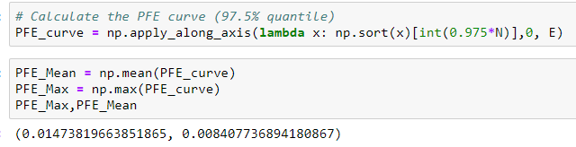

Table 12: PFE Curve

We will use the numpy function to calculate the PFE curve.

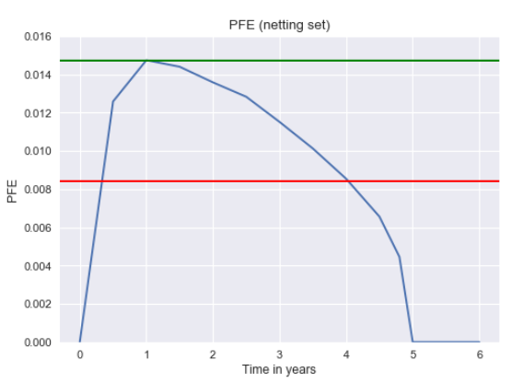

Graph 6: PFE curve with max and mean.

This curve should show less convex exposure over tenors than EE.

### Step 7: Calculating the default probability and CVA

To derive the default probability we can use the market implied quotes like CDS or use rating information

We will take an invented CDS curve

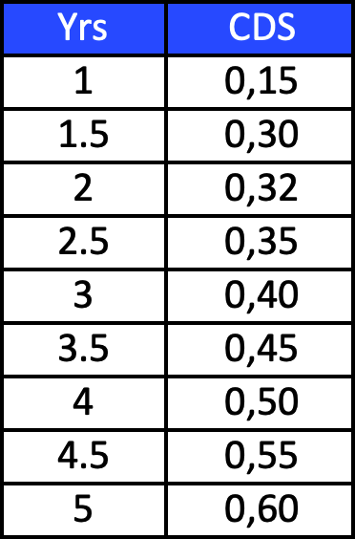

Table 13: CDS Curve

With the CDS curve, we will Bootstrap it to obtain the hazard curve and the PD curve.

We will denotate PV float(T) the present value of the default leg (Value of the payment that buyer of default protection up to time T). PV fix (T) will denotate the value of the payment that’s represent value of the cash stream that must be paid in exchange for the default protection until T.

By contractual stipulation, at inception a CDS must be wortless, that’s is

we will call S(T) the fair spread at inception for the CDS. S can be factored out of the payment leg

P is the value of protection per rate unit

We will assume that the interest rate process is indepent of the default process and the default leg pays at the end of each accrual period. With this we can write

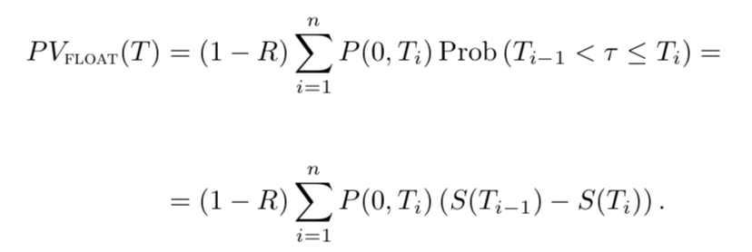

For the fee leg, regular fee pays occurs at the end of each period. When default occurs, one last fee payment corresponding to the accrued fee for that period is contractually required. One way to model is to making an assumption on the ocurrent of default and the actual payment. We that the JP morgan model that’s assume the default occurs midway during each payment period, but the accrual payment is made at the end of the periods. These assumption yield the following value for the fee leg

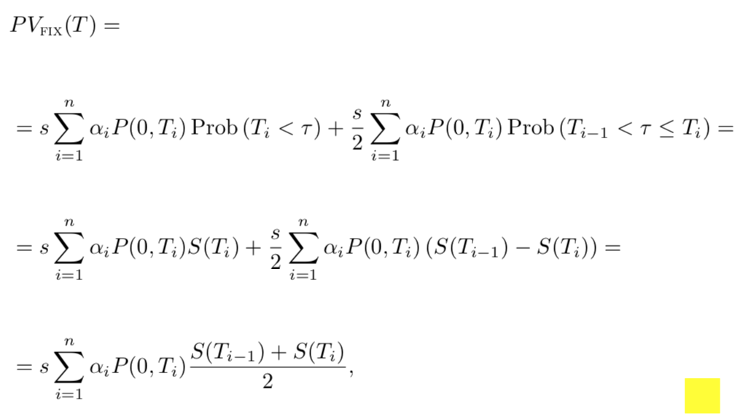

Where are the fractions corresponding to the period

Given the values for and we can writes the value of the CDS with maturity as

Let assume that we have liquid spreads for the m maturities

We assume that the hazard rate is piecewise constant on the intervals that correspond to the CDS Contracts

for and k = 1,2,.. ,m

we start to solving for using the value of the first conrtact spread

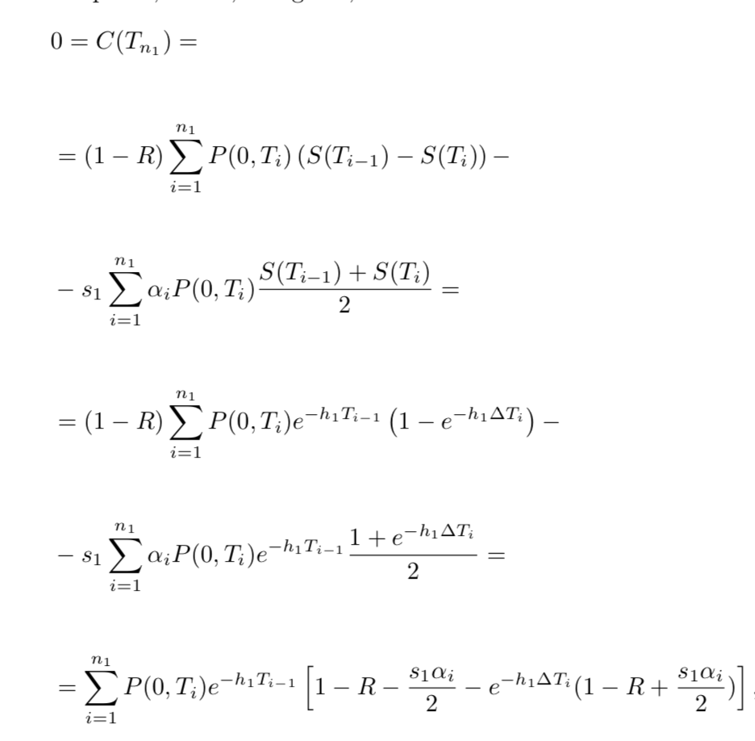

now we need to solve for . If we assume that the accrual factors are identical and we assume that the calendar time between payments are identical (Bootstraping the CDS curve)

For the CDS curve we obtain the Hazard Rates

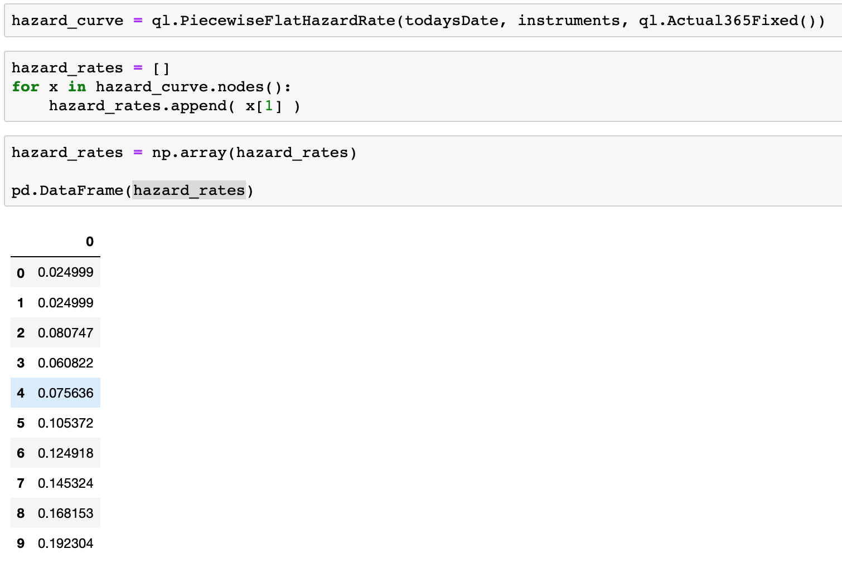

Table 14: Hazard Rates

And we can obtain the PD curve with QuantLib module in Python.

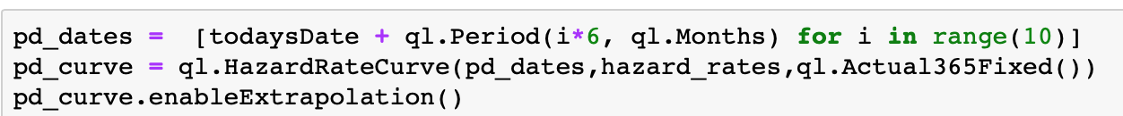

Table 15: PD curve

Now with the default probabilities we can calculate the CVA Charge

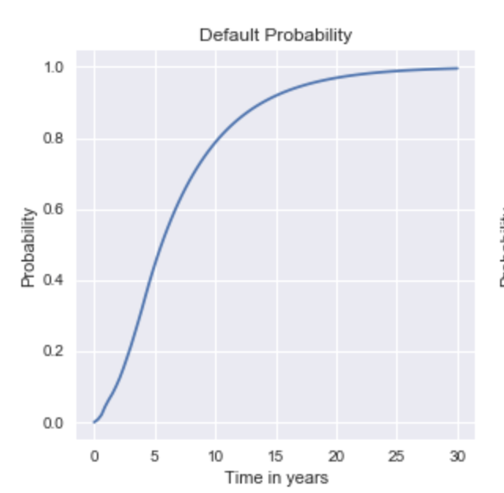

Graph 6: PFE curve with max and mean.

We calculate CVA with 8 different Discounted expected exposure parameters.

CVA = sum of vector

CVA _1 = DEE max

CVA _2 = DEE percentile 97,5

CVA _3 = DEE quantile 90

CVA _4 = DEE quantile 80

CVA _5= DEE quantile 75

CVA _6 = DEE quantile 60

CVA _7 = DEE Mean

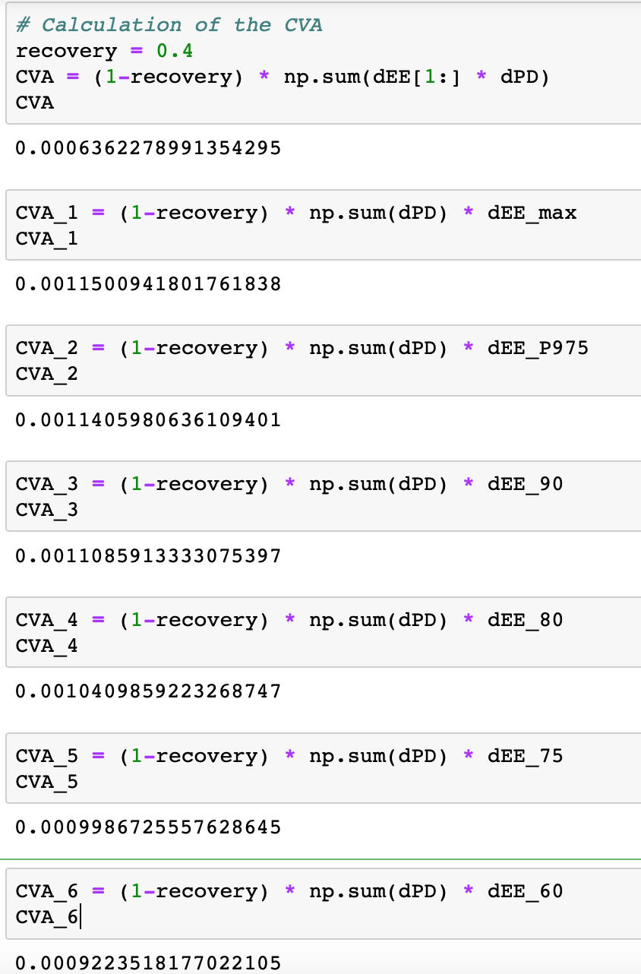

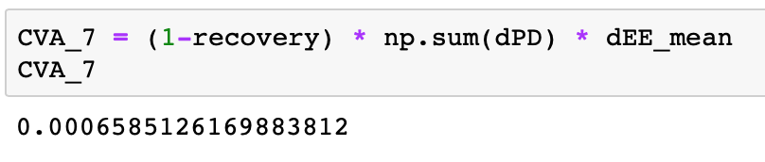

Table 16: Calculations for the CVA

# Sensitivity analysis

We will calculate again the value for the CVA but with the maximum exposure, mean

exposure, 97,5 percentil exposure.

We will calculate again the value for the CVA but with the half of the historical data.

We will calculate again the value for the CVA but with the half of simulation in Montecarlo

(1.000 simulations).

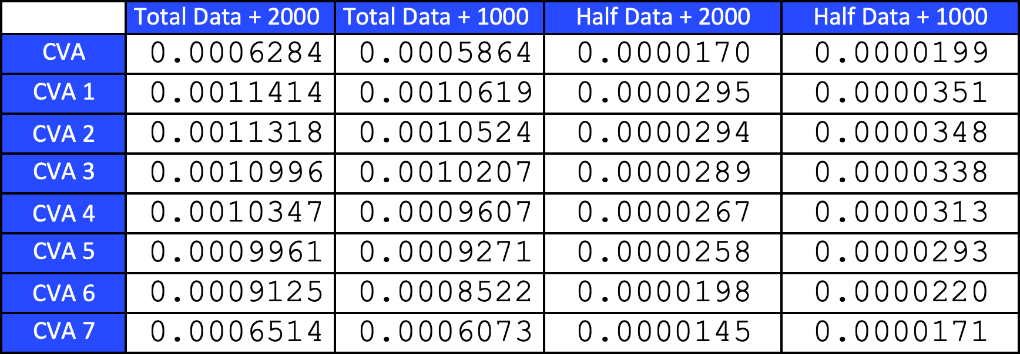

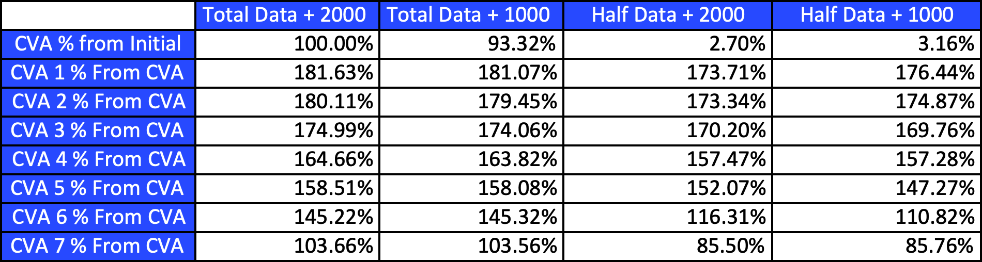

# Conclusions

We implement a Libor market Model to calculate CVA Charge. We choose Python

because it have a fully fledged programming language but easy to understand. Python

afters powerfulls libraries making easier to program using codes already made like

Numpy or QuantLib Libreries.

The model

# References

https://www.investopedia.com/terms/c/creditdefaultswap.asp

[https://en.wikipedia.org/wiki/Black_](https://en.wikipedia.org/wiki/Black_model)[[https://en.wikipedia.org/wiki/Bootstrapping_(finance)](https://en.wikipedia.org/wiki/Black_model)](https://en.wikipedia.org/wiki/Bootstrapping_(finance))

[model](https://en.wikipedia.org/wiki/Black_model)